Concept Map for Smoking cassation and Alcohol Abuse
Name
Institution Affiliation
Course
Date

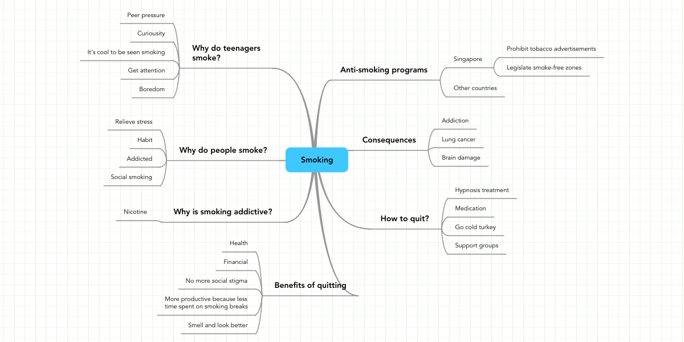
The above concept map presents a general strategy for smoking cessation and drug abuse. This concept map's main objective is to educate residents on smoking cessation and other drug abuse such as alcohol to create awareness and minimize drug abuse. The concept map begins to pinpoint why most youths engage in drug abuse, mainly smoking. Many teenagers involve themselves in drug abuse activities because they are bored and want to get attention from their peers, peer pressure, and curiosity. In contrast, others assume it is cool to be seen smoking and abusing other drugs. This is a very significant step in smoking cessation and other drug abuse as it educates youths to avoid activities or situations that might drive them into such immoral behaviors.
The concept map also covers anti-smoking behaviors like enforcing laws prohibiting smoking and other drug abuse among youths. Notably, the map covers conceptual reasons why adults engage in drug abuse and, at the same time, indicating the side effects of smoking. Some of the consequences of smoking include lung cancer, brain damage, and addiction (Hu et al.,. 2018). I believe with this kind of information, and most people can keep away from drug abuse and smoking.
The concept map concludes by indicating the benefits of quitting smoking. However, cutting back on or stopping smoking and other drug abuse may cause drug withdrawal symptoms. Smoking cessation and stop drug abuse are both mental and physical. Physically, the body is reacting to the absence of certain addictive drugs. In contrast, mentally, the mind is challenged in giving up smoking activities or drug abuse, which might call for significant changes in one's behavior.

Reference
Hu, Y., Zong, G., Liu, G., Wang, M., Rosner, B., Pan, A., ... & Sun, Q. (2018). Smoking cessation, weight change, type 2 diabetes, and mortality. New England Journal of Medicine.

